Project Description
We have discovered a new approach to nuclear fusion that is remarkably simple. Our results have been peer-reviewed and published in Nature Scientific Reports in May 2024 (doi:10.1038/s41598-024-62055-6). The method involves suspending solid titanium deuteride (TiD) particles in mineral oil in presence of heavy water (D₂O) bubbles / droplets and subjecting said suspension to periodic acoustic influence. Our experimental reactor is shown on Fig. 1 and the corresponding reactor block diagram is shown on Fig. 2.
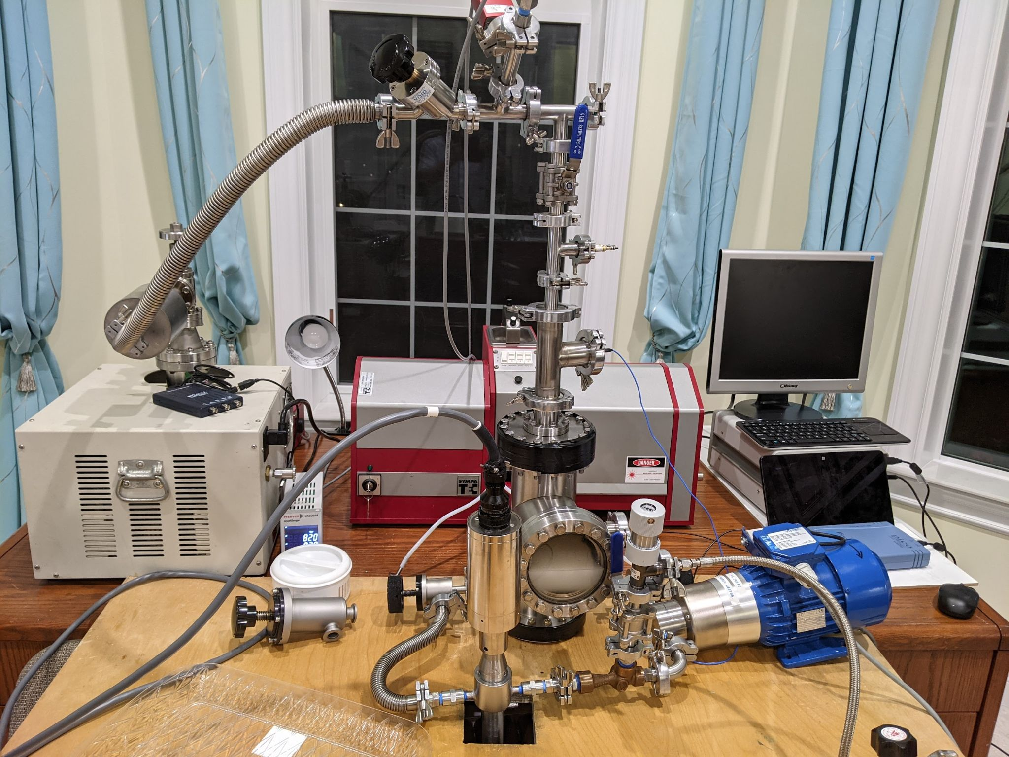
Fig. 1. The experimental reactor.
OIL+D₂O+TiD
BRANSON SONIFIER 550

REACTOR
VACUUM
PUMP
P

D₂ CYLINDER

PIEZO AMPLIFIER
PCB 113B23
SCOPE

AUTOMATED NUCLEAR LAB
³He
TUBES
PIEZO DRIVER

CIRCULATION PUMP
VENTURI
OIL FILTER
CAVITATION CHAMBER
101-021-004

Fig. 2. The experimental reactor block diagram.

The reactor is a 6” conflat vacuum tee with a viewport filled with a working fluid, which is a suspension of solid TiD particles and D₂O bubbles / droplets. The reactor is connected to a recirculation loop with a magnetic pump (blue), venturi nozzle and a secondary cavitation chamber, a SympaTEC HELOS/Sucell inline particle size analyzer (red) and a vacuum pump system (beige). The main acoustic driver is a Fisher SFX 500 Watt / 20 kHz piezoelectric transducer mounted on the bottom plate of the reactor (not shown). The sound inside the reactor is recorded via a PCB Piezotronics 113B23 piezoelectric transducer connected to a digital oscilloscope.
A typical experimental protocol is as follows: the oil is initially deposited into the reactor and degassed using the vacuum pumping system with occasional cavitation via the main driver. Then a separately prepared suspension of TiD with D₂O is introduced into the reactor (various volumes, from 1 to 500 mL). Then after mixing the main acoustic driver is activated at 100% power in pulsed mode (0.01 seconds on / 0.01 seconds off cycle). If the conditions inside the reactor are right then a significant neutron flux is registered by a neutron detector assembly comprising six LND 251106 ³He-filled proportional neutron counters (Fig. 3) located in the back of the reactor.
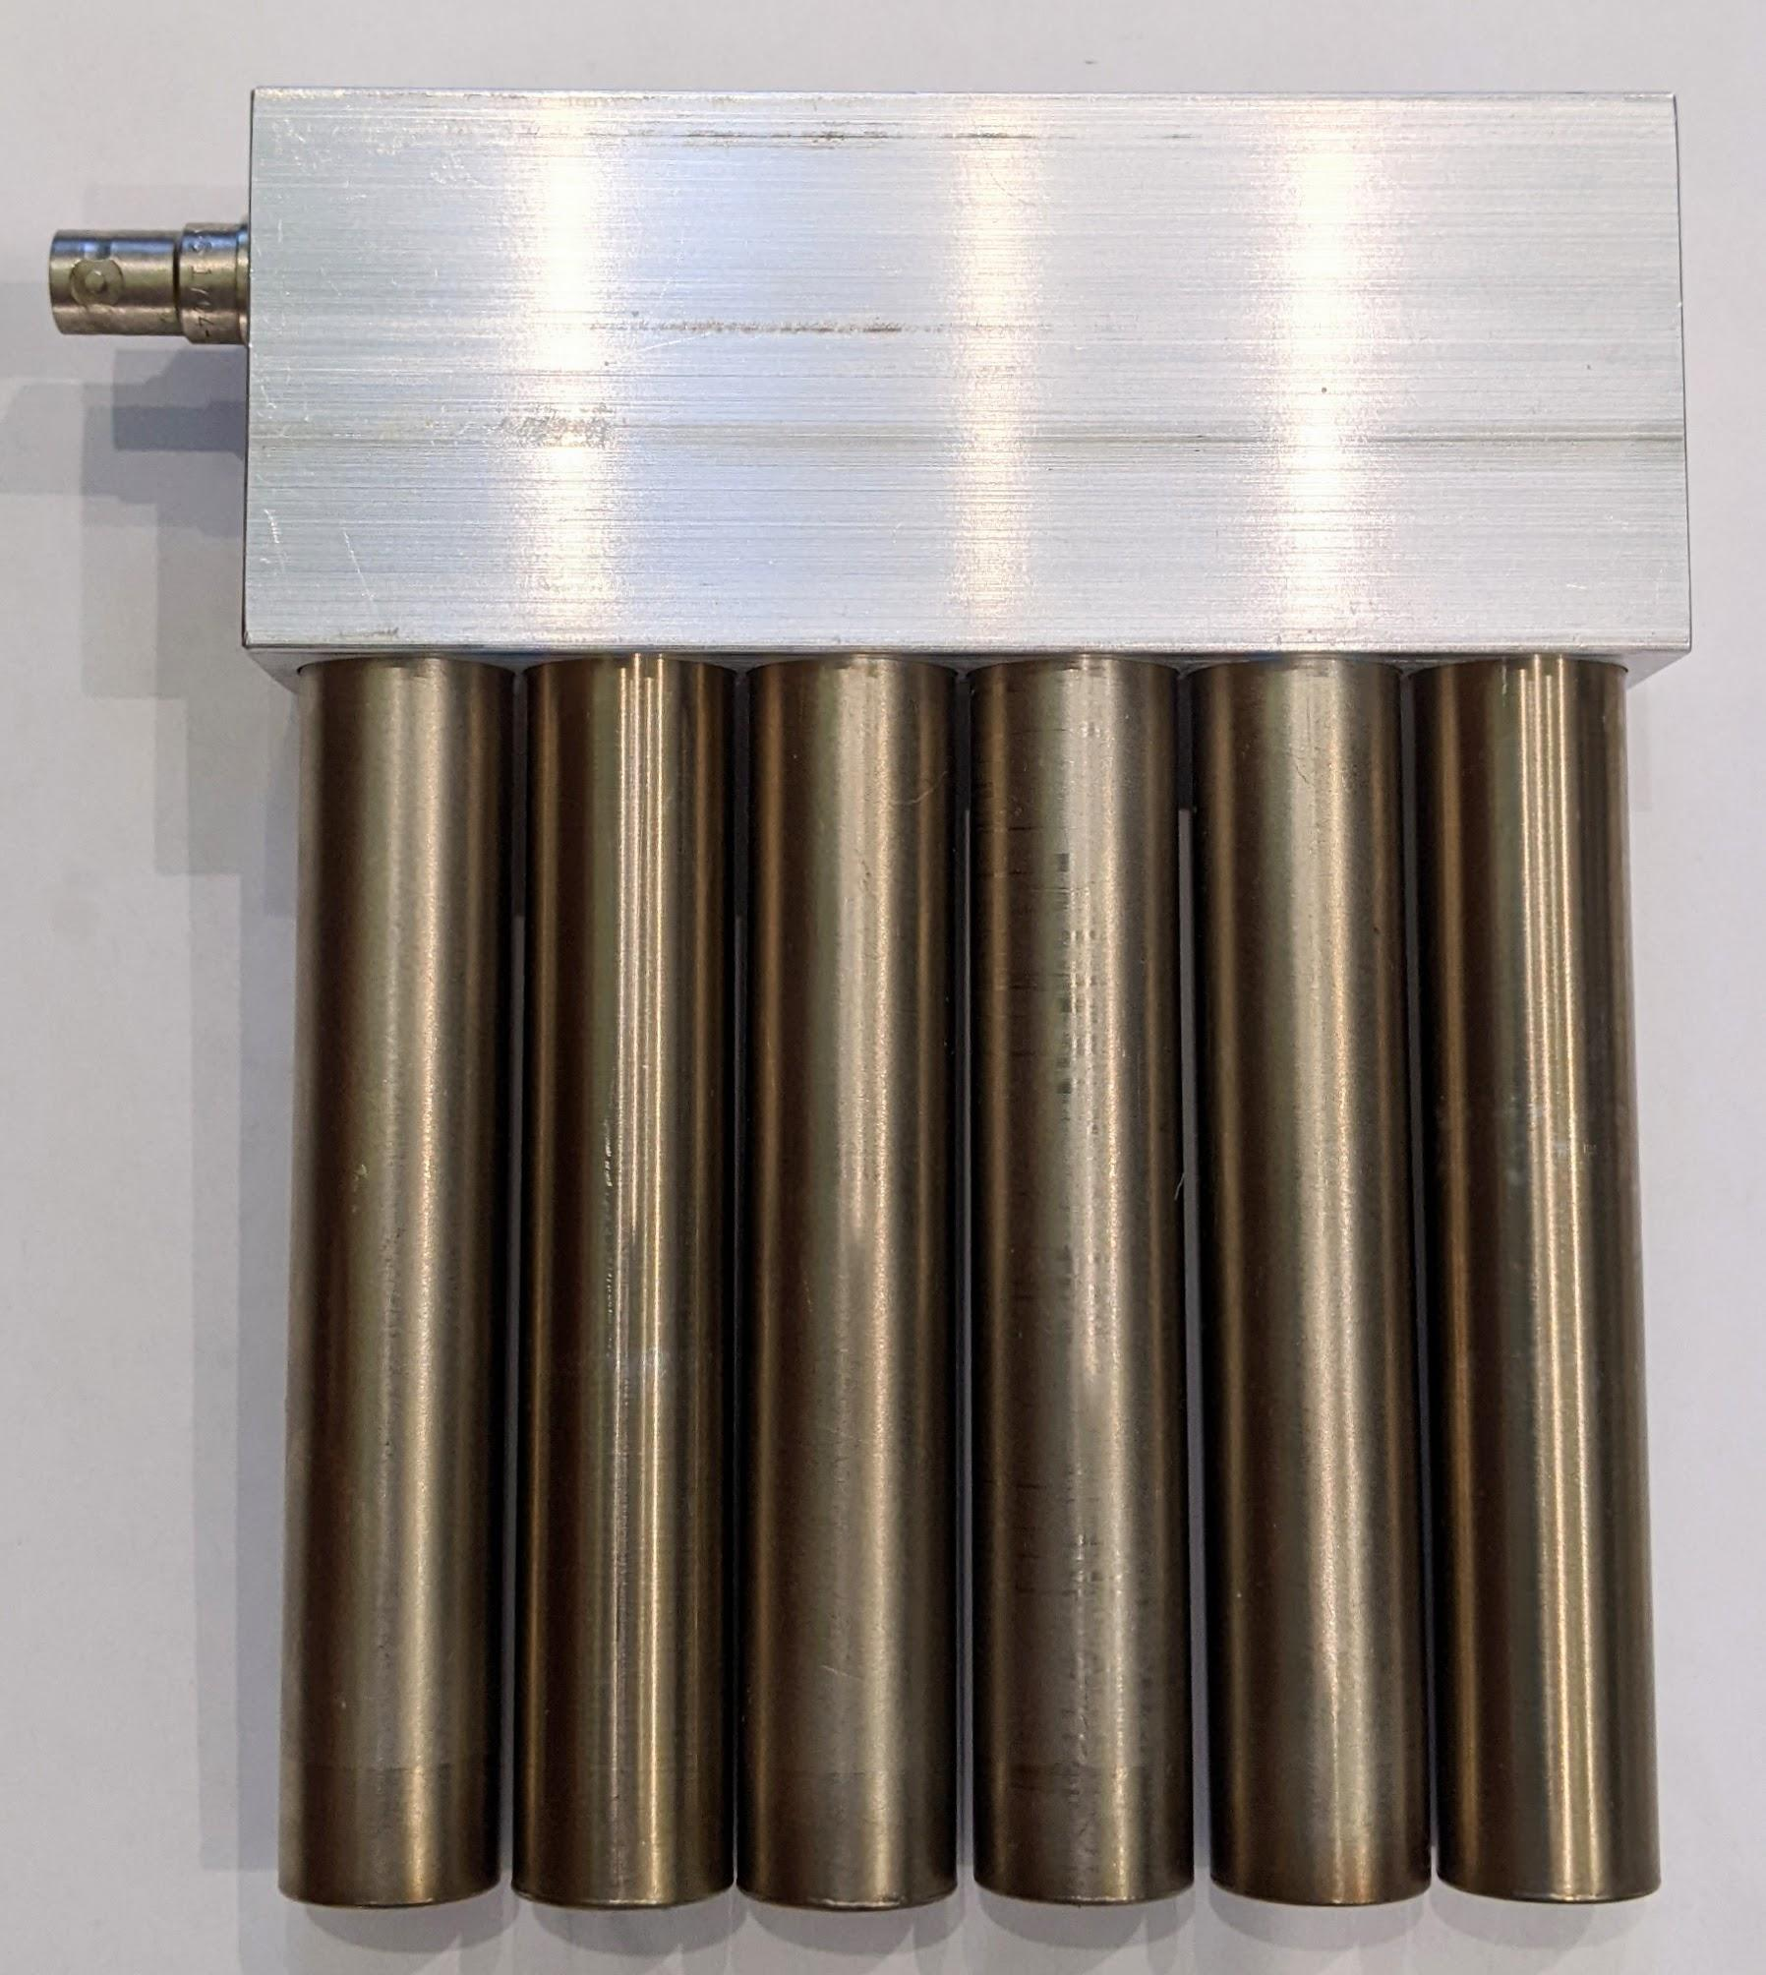
Fig. 3. The neutron detector assembly of six LND 251106 ³He proportional counters.
The purported nuclear fusion is identified by significant neutron flux coinciding with the application of sound waves. But before we discuss our results, a few words about our company: Maximus Energy Corporation manufactures, refurbishes and repairs scientific equipment with the emphasis on nuclear radiation detectors. We are a small business and we supply private laboratories, individual researchers, universities and the U.S. government research labs with our unique hardware / software system developed to enable rapid nuclear experimentation - the Automated Nuclear Lab (ANL) [1], Fig. 4.
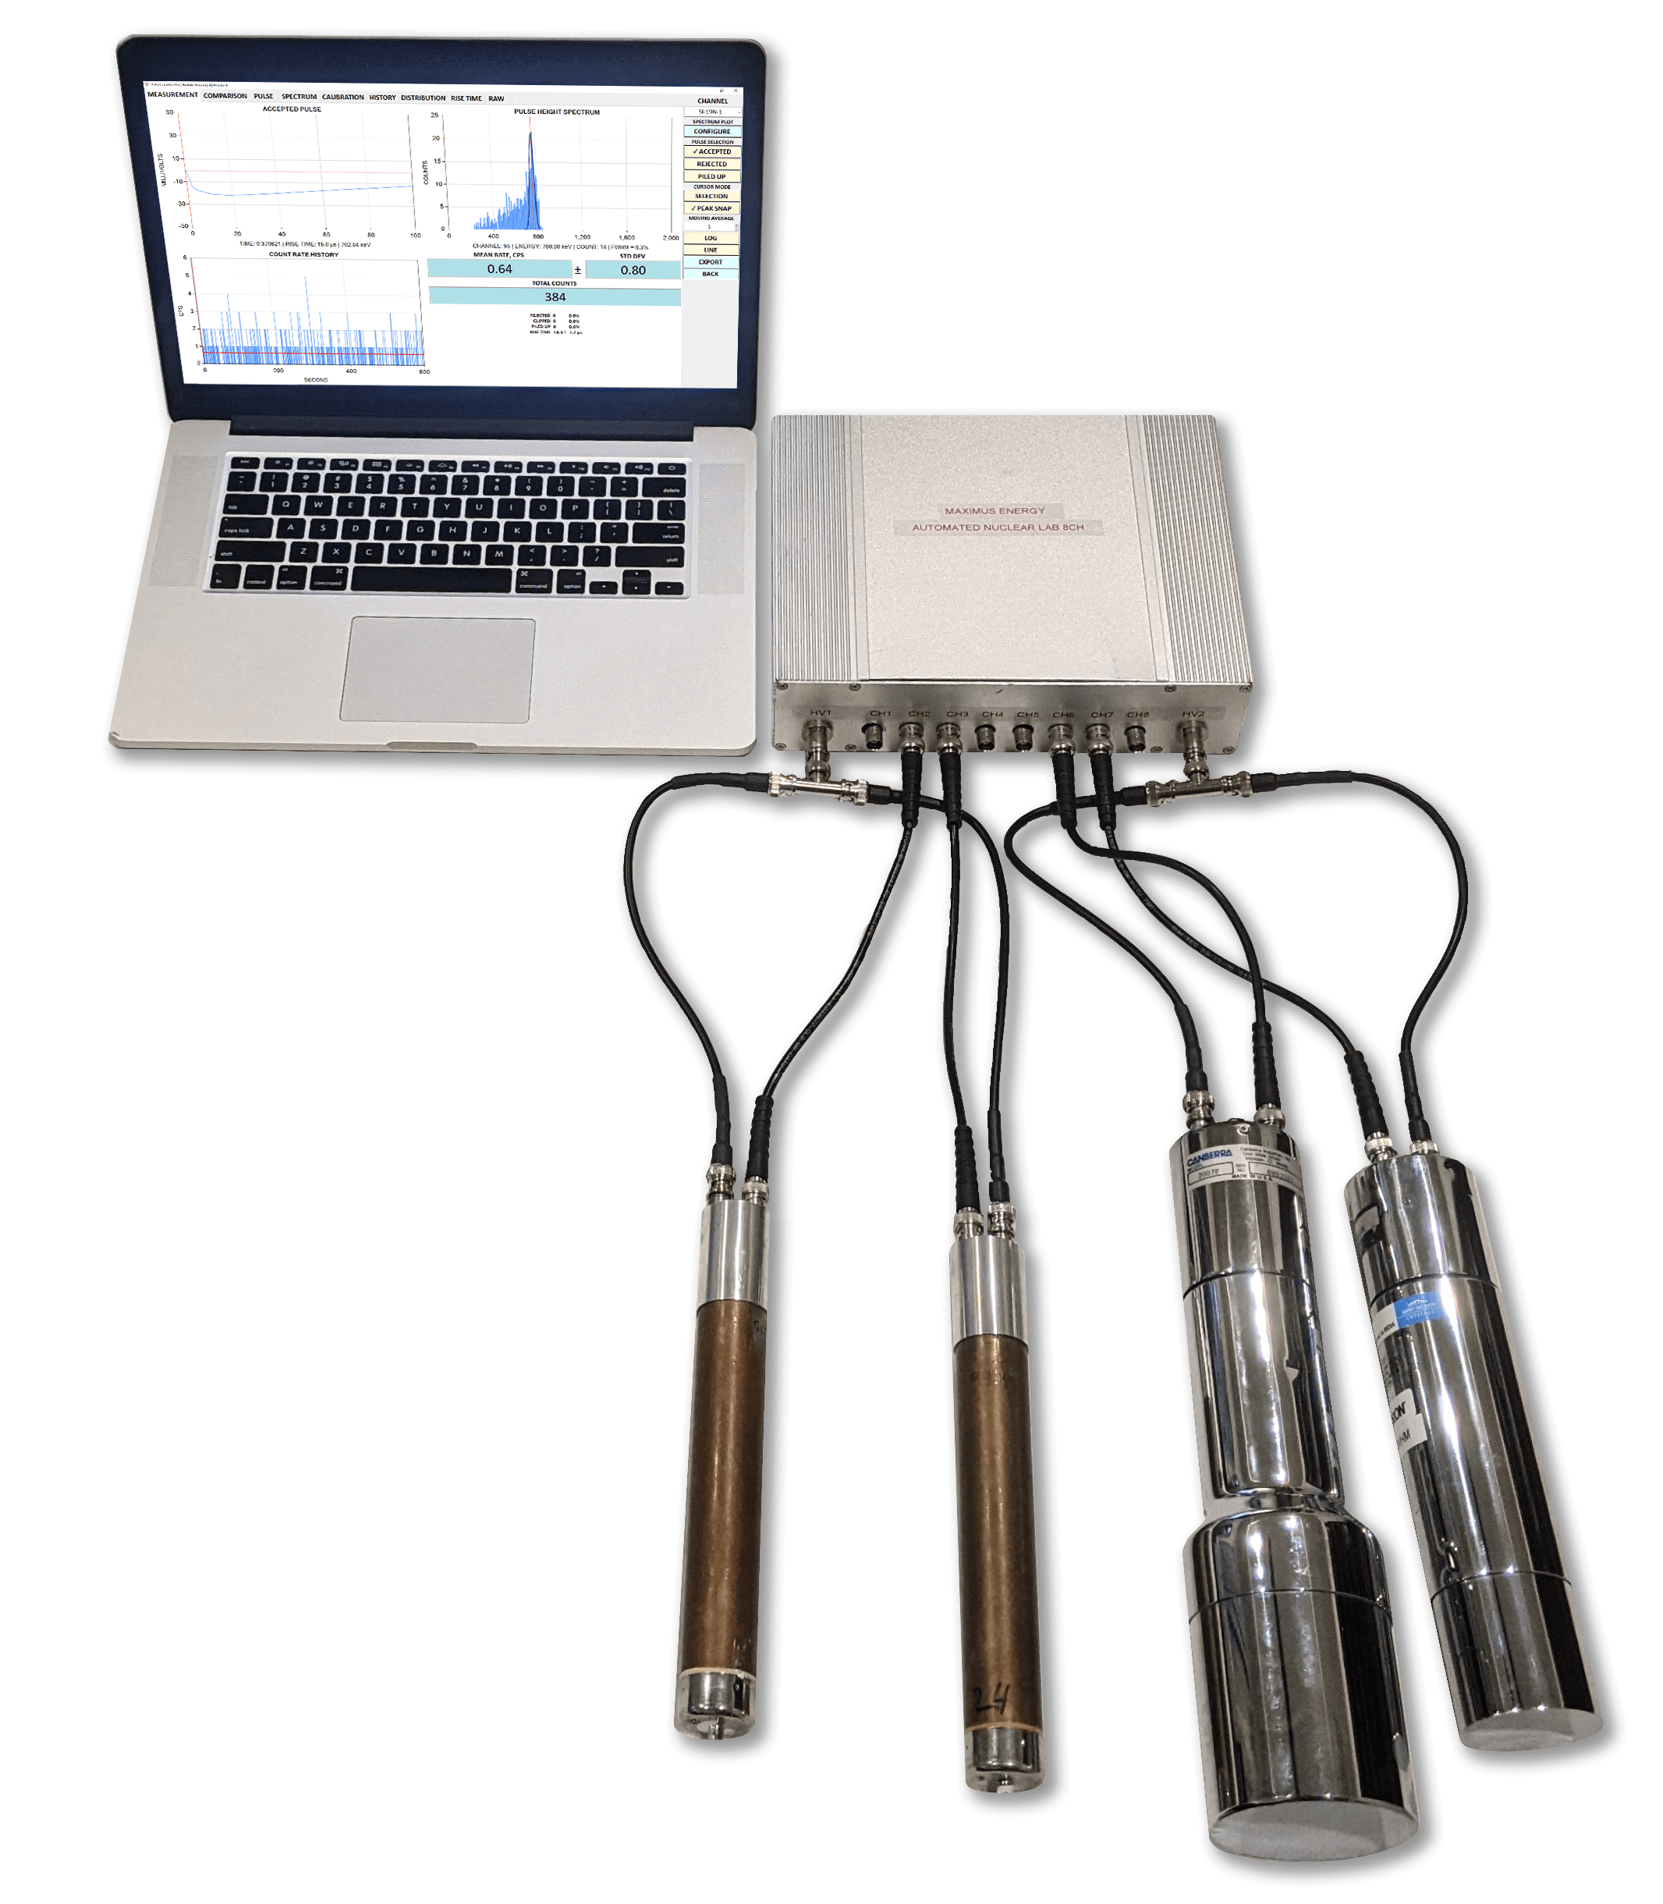
Fig. 4. The Automated Nuclear Lab system.
The ANL hardware comprises a unique multichannel analyzer / pulse processor capable of acquiring and processing signals from up to eight instruments at the same time [2]. Supported instruments are:
- scintillators,
- proportional counters,
- solid state detectors,
- and general purpose analog sensors.
ANL is controlled by our PulseCounter Pro software [3], which acquires, logs and processes detector signals in real time and outputs pulse counts, pulse height spectra, count rate histograms and other useful information. Additionally, PulseCounter Pro performs the following functions:
- determines statistical significance of the difference between the ‘experiment’ and the ‘background’ count rates (Student’s T-test and P-value calculation),
- evaluates the goodness of fit of count rate histogram to the Poisson distribution,
- allows examination of a raw detector signal including browsing of individual pulses,
- provides numerous controls for tuning the pulse counting algorithm and setting up the rejection of artificial counts due to noise.
In other words, our core competency is radiation detection and we have spent years developing the ANL and PulseCounter Pro hardware / software system to automate and streamline neutron and gamma detection to yield high veracity real-time results supported by seamless statistical analysis.
In all our experiments we used the ANL and PulseCounter Pro. For most experiments we used the neutron detector assembly shown on Fig. 2, although for some experiments we used other brands of helium-3 filled proportional neutron counters as well as NaI(Tl) gamma scintillators. In all cases we employed a Po-Be source to calibrate our neutron detectors and obtain a thermal neutron spectrum.

Results
Detailed reports of our experimental results are available in [4] and [5]. Here we shall summarize the main observations. When we deposit the TiD + D₂O suspension in the reactor and turn on the main acoustic driver we register a significant neutron flux coincident with the acoustic influence - Fig. 5-6. The highest registered neutron flux was more than 10,000 times in excess of background, the max count rate was greater than 6,000 CPM, the mean background count rate was 0.6 CPM. The acoustic signal from the reactor is shown on Fig. 7.

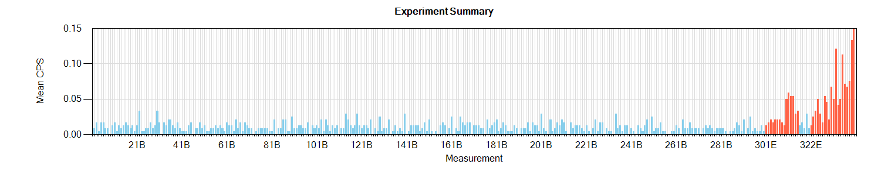
Fig. 5. Neutron counts due to the background (blue) and with the reactor operating (red).
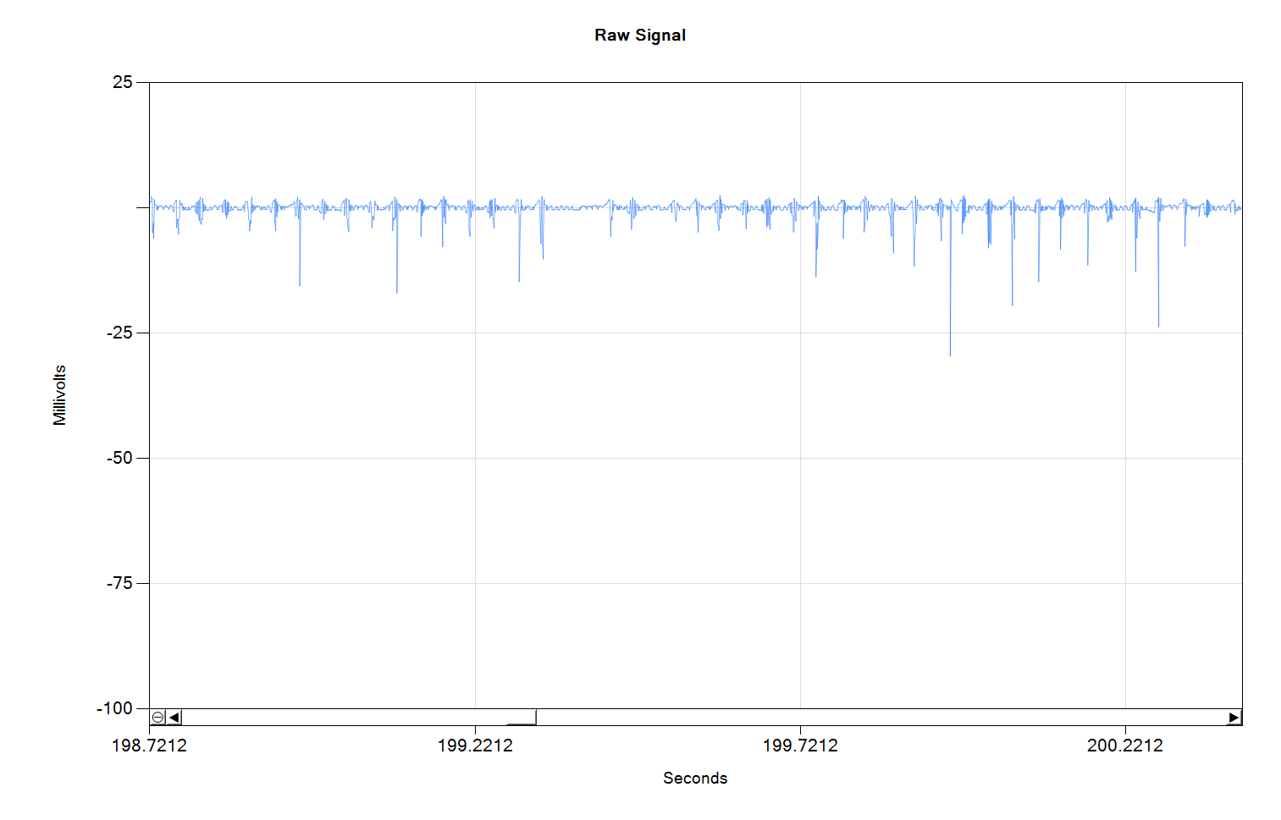
Fig. 6. Raw neutron detector signal: each vertical line is a neutron event; broadening along the baseline is due to capacitive coupling leakage from the activated acoustic driver. Periodic nature of neutron events is clearly coincident with the acoustic driver being active.
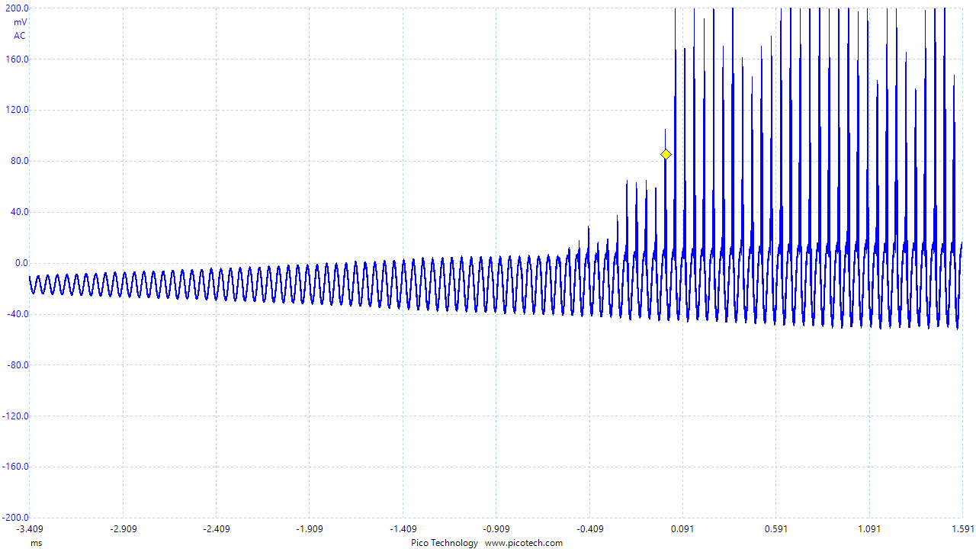
Fig. 7. The acoustic signal from the reactor; massive (clipping) acoustic spikes are evident.
The thermal neutron spectrum acquired over one hour of the reactor operation is shown on Fig. 8.
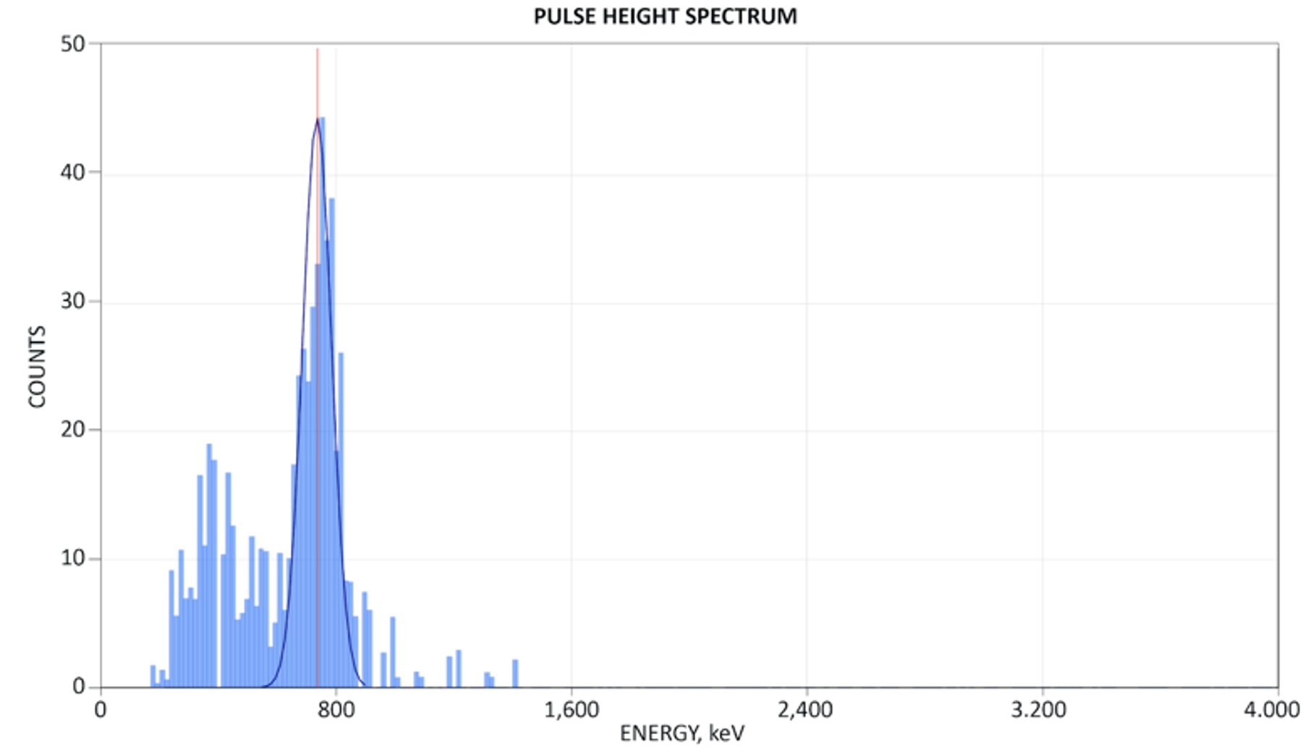
Fig. 8. The thermal neutron spectrum acquired over one hour of the reactor operation.
We hypothesize that nuclear fusion occurs when cavitation jets from the collapsing D₂O bubbles impinge upon the suspended TiD particles forcing deuterium dissolved in titanium lattice to fuse. This process could be related to pyroelectric fusion discovered by Naranjo, Gimzewski and Putterman [6], however, the detailed nature of the process is yet to be determined.
Although we have been able to sustain neutron production for hours, we do not yet fully understand all the conditions necessary to make this process work. Specifically, it is not clear how TiD particle size and concentration is related to D₂O bubble size and concentration. We have also discovered that certain D₂O bubble sizes / concentrations result in extremely powerful secondary acoustic waves (Fig. 7) that we hypothesize originate from the expansion of the rebounding bubbles. These shockwaves add up creating acoustic peaks occasionally exceeding 24,000 psi. Through trial and error we have noted that neutron emission seems to coincide with the presence of these massive acoustic peaks but it has proven difficult to create the conditions necessary for producing said peaks on purpose. The difficulty lies in complex interactions among various bubble populations and strong dependency of the resulting rebounding waves on the bubble size and concentration as well on the acoustic drive frequency and amplitude. To tackle this problem we propose to complete the tasks outlined below.

CFD / OpenFOAM Modeling of Bubble Oscillations
We would like to develop a computational fluid dynamics (CFD) model in OpenFOAM to model a single bubble collapse in conditions present in our experimental reactor. The resulting model will help us predict the magnitude and frequency of the rebounding bubble’s oscillations depending on the magnitude and frequency of the acoustic drive. With such a model we should be able to determine what bubble size in combination with the acoustic drive frequency and amplitude results in the massive 24,000+ psi acoustic peaks that we suspect are necessary for fusion.
We have studied available publications [7, 8] examining the collapsing bubble problem in OpenFOAM and found the OpenFOAM approach sufficiently promising. Therefore we chose OpenFOAM as a starting point for developing our own model. This task involves writing custom CFD code using the OpenFOAM library and modeling bubble collapse in 3D space using various initial conditions found in our experimental reactor.
The first success criterion is the validation of the developed software model against published results where the bubble radius was observed and recorded experimentally [9]. The bubble radius versus time output of our software under the same conditions must match the published results.
The second (advanced) success criterion involves acquisition and setting up of a high-speed (1 million frames per second) camera in order to directly observe a bubble radius evolution inside our reactor. Because all published results are almost exclusively deal with air (or noble gas) bubbles in water under influence of mild acoustic drive (~14 psi), it is desirable to directly observe evolution of a D₂O bubble in mineral oil under the influence of a strong (>> 14 psi) acoustic drive in order to further validate our software model as the conditions that we would like to model are very different from the commonly studied cases. The success of the advanced validation step is determined by two markers:
- Our ability to observe a bubble inside our reactor under relevant conditions and experimentally deriving a bubble radius versus time plot;
- Running our software simulation using the same set of initial conditions and obtaining a bubble radius versus time plot matching the experimental observations.
These two validation steps are necessary to establish the veracity of our software model so we could use it to derive useful predictions about the magnitude of the rebounding shockwaves given a variety of initial conditions.
Principle novelty: water vapor bubble and particularly water droplet dynamics in mineral oil is not well researched; their behavior under the influence of acoustic influence has not been previously theoretically or experimentally studied. We intend to make progress in researching these topics.

Microfluidic System for Microbubble / Microdroplet Generation
We must develop a microfluidic system for generating D₂O microbubbles / microdroplets of a precisely controlled specified size resulting in a narrowly-peaked bubble size distribution. Currently we can generate only broad-peaked bubble size distributions, which typically results in unpredictable behavior as bubbles of vastly different sizes interact chaotically making consistent results difficult to replicate and study. We use SypmaTEC HELOS laser diffraction system and MicroTrac Nanotrac digital light scattering system to measure particle size in fluids.
On the surface this looks like a simple task as numerous vendors offer microfluidic systems for generating microbubbles and microdroplets. However, all of the available systems are designed to generate oil droplets in water and none are made to generate water droplets in oil. This phase reversal makes all the difference and presents an interesting but not an impossible challenge. Specifically, due to high viscosity it is difficult to achieve the desired flow rate of oil necessary for production of the water in oil droplets. As such we must experiment with various microfluidic systems and upgrade them to withstand higher temperatures (heating reduces oil viscosity) or higher pressures or both. Durability of microfluidic chips is also in question as they are typically made of plastic. We are proposing to purchase the Elveflow Droplet Pack system [9] as a starting point for our engineering process.
The success criterion is the ability to generate a narrow, single-peak particle size distribution of vapor bubbles or water droplets in mineral oil. The intended particle size is between 1 and 100 micron. At this stage we do not know what exact size will work best. So any sharp, single-peak size distribution in this range will be deemed a success. Additionally we hope to learn how to influence the droplet size by controlling the flow rate so we could eventually produce bubbles / droplets of any desired size within a given range. This second goal may be too ambitious for this early stage and therefore we regard it as optional.
Principle novelty: vapor bubbles or water droplets in oil are generally not being synthesized in microfluidic systems. We intend to make progress in researching this topic.

Broader Impacts
Mastery of nuclear fusion in solid state can lead to extremely simple, inexpensive nuclear fusion reactors and neutron generators that have moving parts. Such reactors would not require expensive and extremely technologically challenging plasma containment systems. Potential applications are in low cost / low hazard power generation, non-destructive diagnostics (neutron imaging), and medical isotope synthesis for nuclear pharmacology.
Indeed, when one thinks of nuclear fusion, multi-billion dollar installations like ITER or National Ignition Facility (NIF) come to mind. These are extremely technologically advanced projects that require collaborations of hundreds of scientists from dozens of institutions. Our discovery of a significant amount of neutrons originating from solid TiD particles suspended in mineral oil under the influence of mechanical agitation offers an alternative, much simpler and much cheaper approach to fusion.
At this early stage it is difficult to gauge economic viability of our approach, but we submit that at the very least this approach deserves further study so we could understand the physics of the process and eventually answer the question: can we scale it up? If we can scale it up 1,000 times we can potentially offer a low-cost neutron generator for medical isotope production. If we scale it 10,000 times we can potentially offer an inexpensive system for non-destructive neutron imaging. If we can scale it 1,000,000 times we can potentially offer a small, portable fusion power generator at the cost of a car engine. These prospects make us very excited to apply for this Phase I SBIR award because the potential applications of a small form factor / low cost fusion technology are nothing short of revolutionary. But should we fail, the knowledge that we hope to obtain in the process may help others to succeed in pursuing other novel and under-researched pathways to commercially feasible fusion energy.

